Edge Integration cell (EIC) from Developer perspective
Edge Integration Cell (EIC) is intentionally designed to feel very similar to SAP Cloud Integration, but there are a few key differences to keep in mind:
Development Similarities
- Same design-time tools:
You still use SAP Integration Suite’s web-based Integration Designer in BTP to model iFlows, mappings, and APIs.
- Same artifacts:
Integration Flows, API Proxies, Value Mappings, Script Collections, etc. are identical.
- Deployment options:
From the same cockpit, you can choose whether to deploy an artifact to Cloud Runtime or EIC Runtime.
- Monitoring:
Centralized monitoring (message monitoring, deployment status) remains in the BTP Cockpit, regardless of runtime.
So as a developer, your experience in Web UI is nearly unchanged.

Development Differences (EIC vs. Cloud Integration)
1. Runtime Target Choice
- Cloud Integration → You design and deploy to SAP-managed cloud runtime.
- EIC → You design in the same place, but deployment is redirected to your on-premise Kubernetes runtime.
Developer impact: Need to be aware of where artifacts are executed (e.g., compliance-sensitive vs. SaaS-facing).
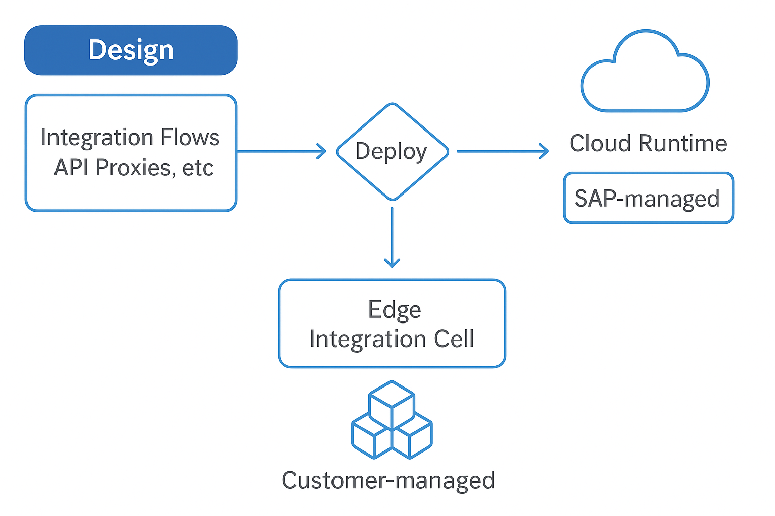

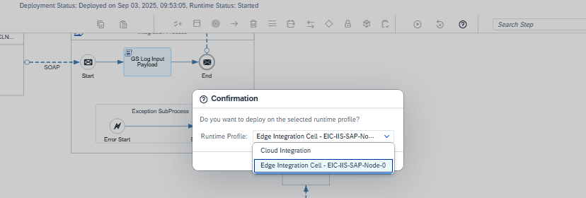

2. Connectivity
- Cloud Integration → Requires SAP Cloud Connector or internet-facing endpoints to connect on-prem.
- EIC → Can directly connect to local backend systems (SAP ECC, S/4, legacy apps) without Cloud Connector.
Developer impact: Simplifies development for on-prem flows (no tunnel setup, easier testing).
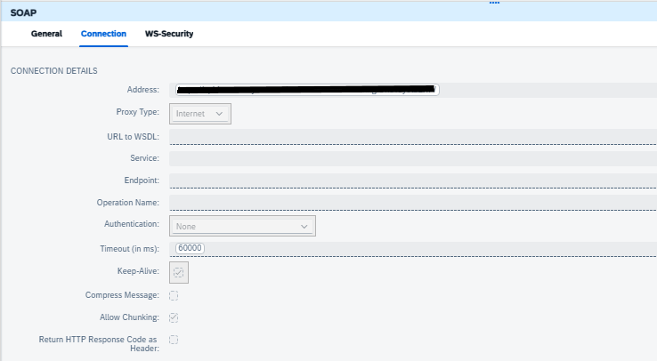

3. Adapters & Features Availability
- Cloud Integration → Full adapter library (IDoc, RFC, JDBC, SFTP, AS2, etc.) and B2B capabilities.
- EIC → Still maturing; some adapters/policies aren’t yet supported (e.g., B2B partner directory, certain OAuth flows, some legacy adapters).
Developer impact: Must check supported adapter list before designing for EIC.

4. Testing & Debugging
- Cloud Integration → Test messages go through cloud runtime; latency depends on internet.
- EIC → Local runtime allows faster tests for on-prem system integrations.
Developer impact: Quicker dev/test cycles for local systems.
- 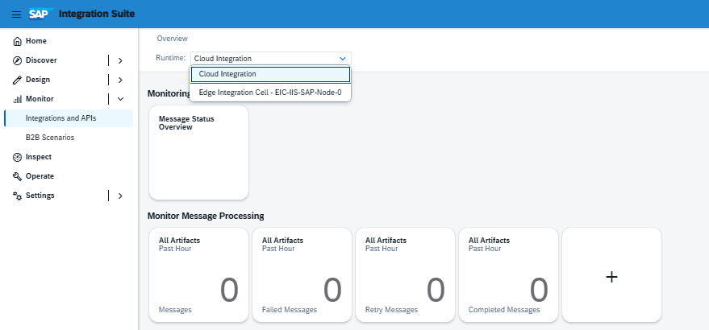
- 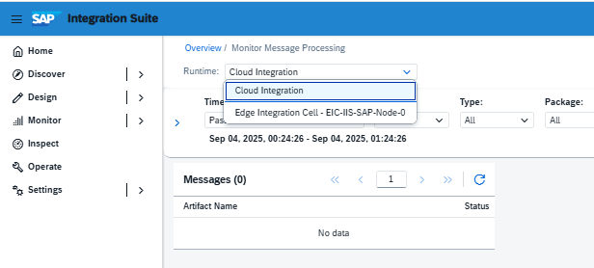

5. Offline Development Scenarios
- Cloud Integration → Always needs internet to SAP BTP to design/test.
- EIC → Runtime can execute offline temporarily, but design time is still in the cloud.
Developer impact: No change in dev, but runtime resilience helps test fault scenarios.

6. Operations & Lifecycle
- Cloud Integration → Runtime updates are SAP-managed.
- EIC → Runtime lifecycle (patching, scaling, container mgmt.) is customer-managed via Kubernetes.
Developer impact: Closer collaboration with infra/DevOps teams needed.
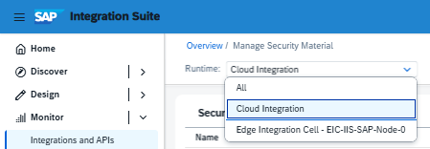
🏗️ Architect’s View
- For developers, the day-to-day experience is 95% the same — design in BTP, deploy, monitor.
- The main difference is runtime target and available adapters.
- For architects, this means you’ll guide teams on when to deploy to cloud vs. EIC depending on compliance, performance, and adapter support.

